Dart-Shaped and Arrow-Shaped Quadrilateral

Dart-Shaped

Definition
# Source: AI Source: Provided by: [Data Path: Persons Table -> ID Column: 1, Name_En Column: Motasem Essam] -> From: [ChatGPT] on [7/25/2026]
A dart-shaped quadrilateral, commonly called a dart, is a concave quadrilateral with two pairs of adjacent congruent sides.
It can be thought of as a concave form of a kite.
For a dart $ABCD$, a typical arrangement is
$$AB=AD$$
and
$$BC=CD.$$
Unlike a convex kite, one interior angle points inward, creating a reflex angle.
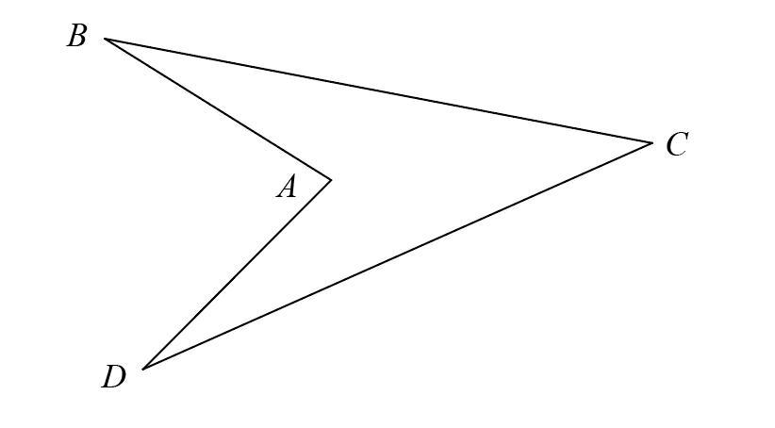
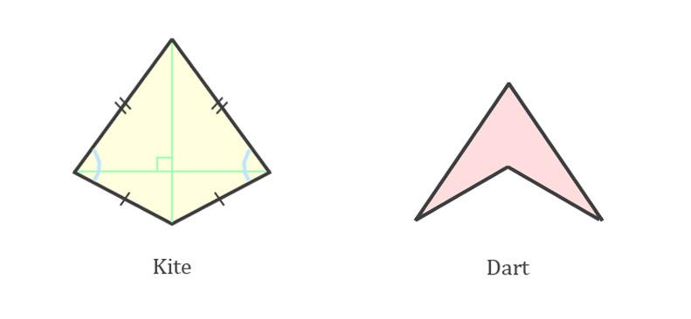
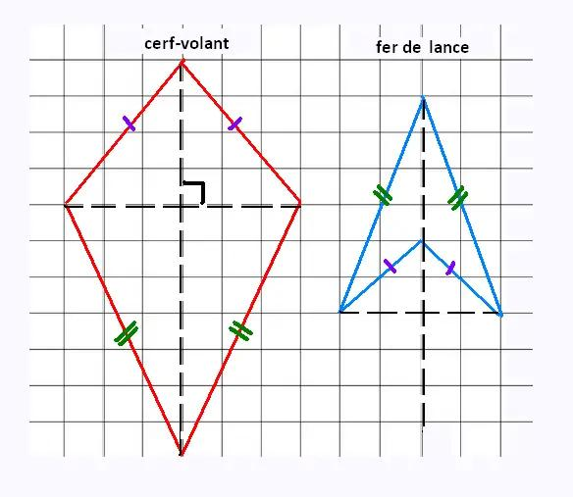
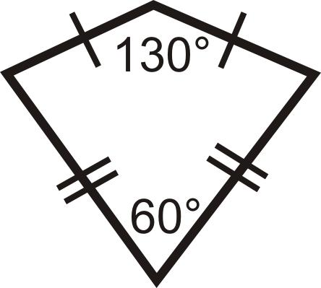
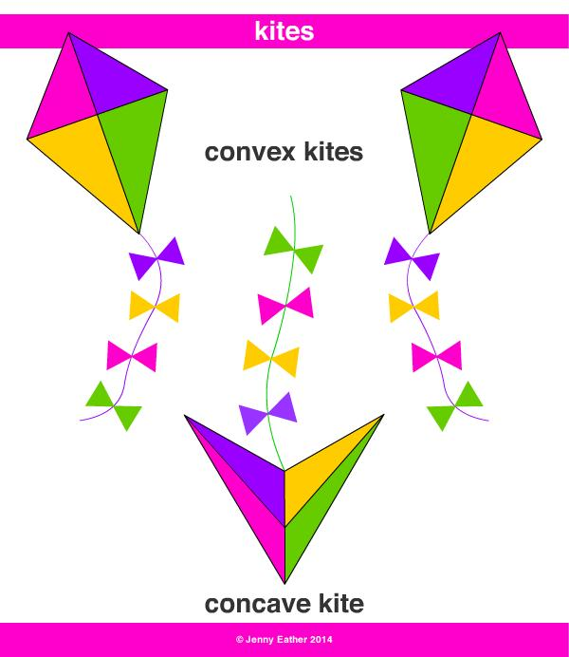

Purpose
# Source: AI Source: Provided by: [Data Path: Persons Table -> ID Column: 1, Name_En Column: Motasem Essam] -> From: [ChatGPT] on [7/25/2026]
A dart-shaped quadrilateral is useful for:
- Studying concave quadrilaterals.
- Understanding the relationship between darts and kites.
- Studying reflex angles.
- Analyzing diagonals of concave figures.
- Calculating area and perimeter.
- Understanding symmetry in concave geometric figures.

Fundamental Elements
# Source: AI Source: Provided by: [Data Path: Persons Table -> ID Column: 1, Name_En Column: Motasem Essam] -> From: [ChatGPT] on [7/25/2026]
Consider dart $ABCD$, where
$$AB=AD$$
and
$$BC=CD.$$

1. Vertices
# Source: AI Source: Provided by: [Data Path: Persons Table -> ID Column: 1, Name_En Column: Motasem Essam] -> From: [ChatGPT] on [7/25/2026]
The four vertices are
$$A, B, C, D.$$
One vertex points inward, producing the characteristic dart shape.

2. Sides
# Source: AI Source: Provided by: [Data Path: Persons Table -> ID Column: 1, Name_En Column: Motasem Essam] -> From: [ChatGPT] on [7/25/2026]
The four sides are
$$\overset{‾}{AB}, \overset{‾}{BC}, \overset{‾}{CD}, \overset{‾}{DA}.$$

3. Congruent Side Pairs
# Source: AI Source: Provided by: [Data Path: Persons Table -> ID Column: 1, Name_En Column: Motasem Essam] -> From: [ChatGPT] on [7/25/2026]
The two pairs of adjacent congruent sides are
$$\boxed{AB=AD}$$
and
$$\boxed{BC=CD}.$$

4. Reflex Angle
# Source: AI Source: Provided by: [Data Path: Persons Table -> ID Column: 1, Name_En Column: Motasem Essam] -> From: [ChatGPT] on [7/25/2026]
A dart has one reflex interior angle, meaning that angle is greater than ${180}^{∘}$and less than ${360}^{∘}$.
$$\boxed{{180}^{∘}<θ<{360}^{∘}}$$
This is what makes the quadrilateral concave.

5. Diagonals
# Source: AI Source: Provided by: [Data Path: Persons Table -> ID Column: 1, Name_En Column: Motasem Essam] -> From: [ChatGPT] on [7/25/2026]
The diagonals are
$$\overset{‾}{AC}$$
and
$$\overset{‾}{BD}.$$
In a typical dart, one diagonal lies partly or entirely outside the interior of the quadrilateral.
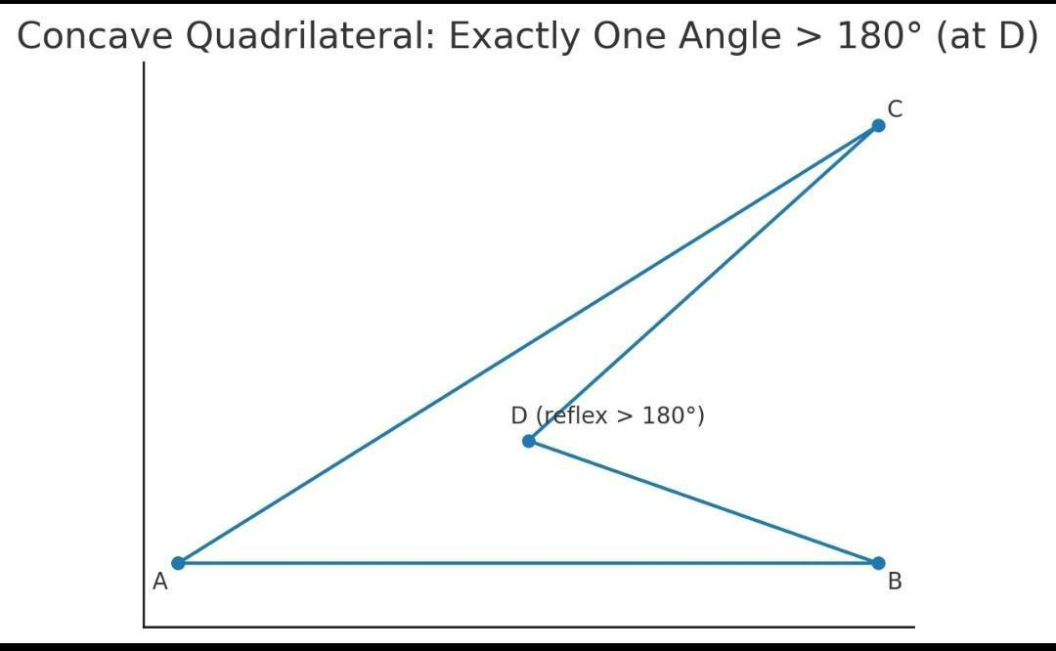
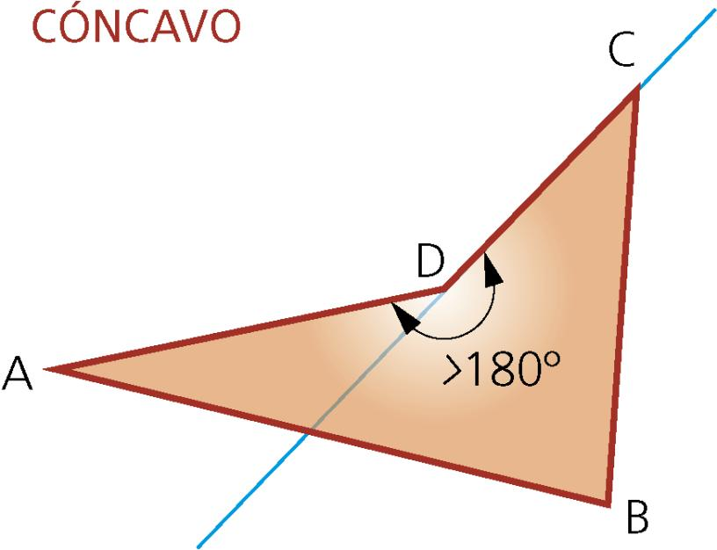
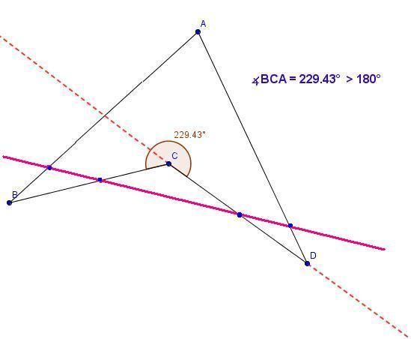

Main Properties
# Source: AI Source: Provided by: [Data Path: Persons Table -> ID Column: 1, Name_En Column: Motasem Essam] -> From: [ChatGPT] on [7/25/2026]
1. It Is a Concave Quadrilateral
A dart is concave because at least one interior angle is greater than ${180}^{∘}$.
Therefore:
$$\boxed{\text{Dart}→\text{Concave Quadrilateral}}$$
This distinguishes it from an ordinary convex kite.

2. Two Pairs of Adjacent Congruent Sides
The defining side relationship is
$$\boxed{AB=AD}$$
and
$$\boxed{BC=CD}.$$
Thus, the dart has the same basic side-congruence pattern as a kite.

3. One Reflex Angle
A typical dart has one reflex interior angle.
For example:
$$∠C={270}^{∘}$$
could occur in a particular dart.
The other three interior angles are less than ${180}^{∘}$.

4. Interior Angles Sum to ${360}^{∘}$
Even though the dart is concave, it is still a quadrilateral.
Therefore,
$$\boxed{∠A+∠B+∠C+∠D={360}^{∘}}$$
when the reflex angle is included as its full interior angle.
For example, if
$$∠A={60}^{∘}, \\ ∠B={40}^{∘},$$
and
$$∠C={270}^{∘},$$
then
$$∠D={360}^{∘}-\left({60}^{∘}+{40}^{∘}+{270}^{∘}\right) \\ \boxed{∠D=-{10}^{∘}}$$
which is impossible.
So those particular angles cannot form a valid dart. The angle values must satisfy the ${360}^{∘}$total while maintaining one reflex angle and three positive non-reflex angles.

Symmetry
# Source: AI Source: Provided by: [Data Path: Persons Table -> ID Column: 1, Name_En Column: Motasem Essam] -> From: [ChatGPT] on [7/25/2026]
A symmetric dart has one line of symmetry.
The symmetry axis passes through the two vertices where the equal side pairs meet.
If
$$AB=AD$$
and
$$BC=CD,$$
then the diagonal connecting $A$and $C$can serve as the symmetry axis in the symmetric case.
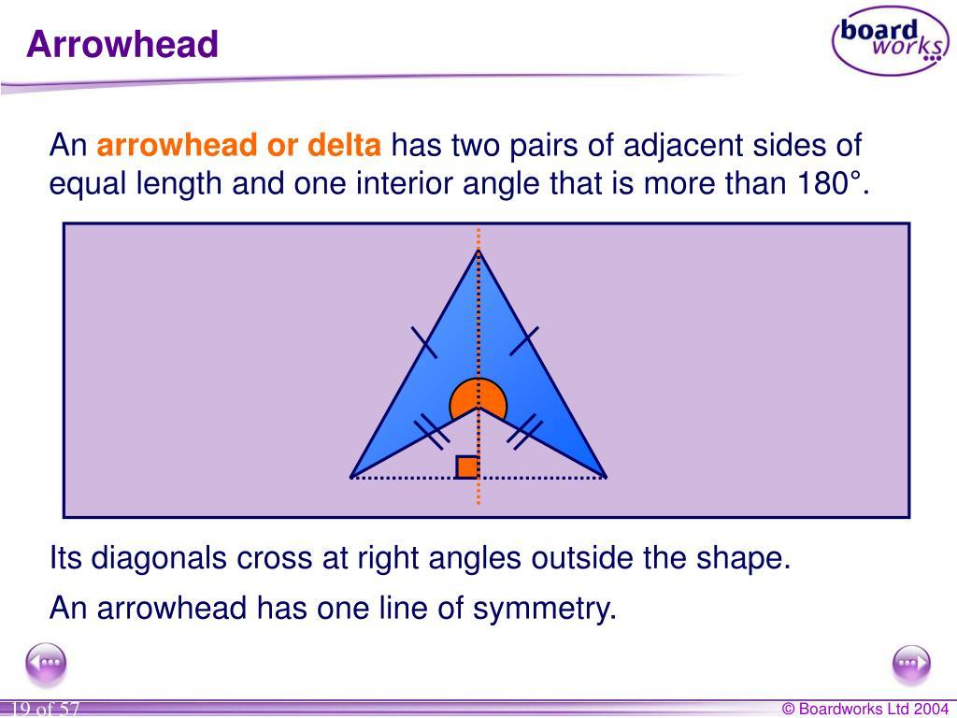
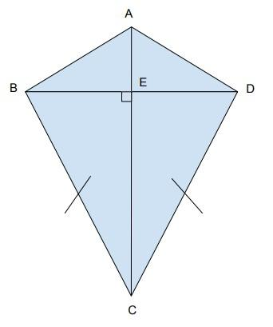
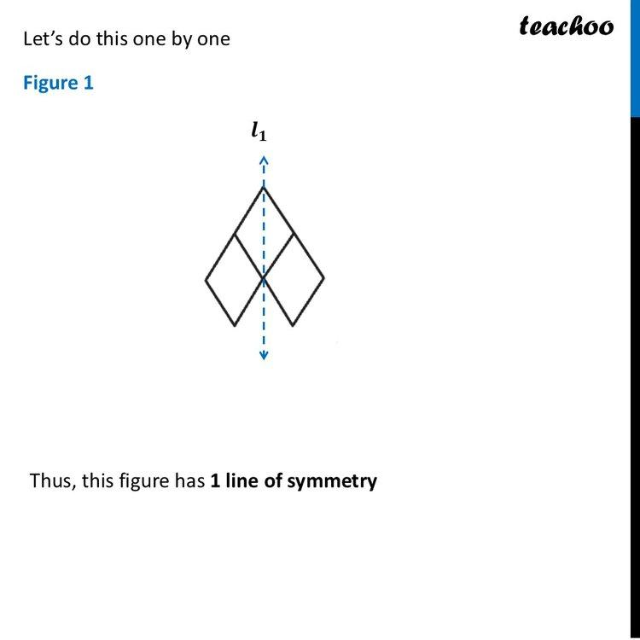
A dart does not generally have rotational symmetry.

Diagonals
# Source: AI Source: Provided by: [Data Path: Persons Table -> ID Column: 1, Name_En Column: Motasem Essam] -> From: [ChatGPT] on [7/25/2026]
Let the diagonals intersect at $O$.
For a symmetric dart, the symmetry diagonal is perpendicular to the other diagonal:
$$\boxed{AC⊥BD}.$$
Thus,
$$∠AOB={90}^{∘}.$$
The symmetry diagonal also bisects the other diagonal in the appropriate symmetric configuration.
The diagonals of a dart should therefore be analyzed differently from those of a general convex quadrilateral.

Area
# Source: AI Source: Provided by: [Data Path: Persons Table -> ID Column: 1, Name_En Column: Motasem Essam] -> From: [ChatGPT] on [7/25/2026]
A dart's area can be calculated by dividing it into simpler regions.
For a symmetric dart, if the two perpendicular diagonal segments have appropriate lengths, the area can be expressed using the same diagonal-area relationship used for a kite, with the geometry interpreted according to the concave shape.
More generally, a safe method is:
$$\boxed{\text{Area of dart}=\text{Area of outer/simple regions}-\text{Area of the indentation}}$$
This reflects the fact that part of the corresponding convex shape is removed.

Perimeter
# Source: AI Source: Provided by: [Data Path: Persons Table -> ID Column: 1, Name_En Column: Motasem Essam] -> From: [ChatGPT] on [7/25/2026]
The perimeter is simply the sum of the four side lengths:
$$P=AB+BC+CD+DA.$$
Because
$$AB=AD$$
and
$$BC=CD,$$
we can write
$$P=2AB+2BC.$$
Therefore,
$$\boxed{P=2\left(a+b\right)}$$
where $a$and $b$are the two distinct side lengths.

Example 1 — Perimeter
# Source: AI Source: Provided by: [Data Path: Persons Table -> ID Column: 1, Name_En Column: Motasem Essam] -> From: [ChatGPT] on [7/25/2026]
Suppose a dart has
$$AB=AD=5\text{ cm}$$
and
$$BC=CD=8\text{ cm}.$$
Then
$$P=2\left(a+b\right) \\ P=2\left(5+8\right) \\ \boxed{P=26\text{ cm}}.$$

Example 2 — Interior Angles
# Source: AI Source: Provided by: [Data Path: Persons Table -> ID Column: 1, Name_En Column: Motasem Essam] -> From: [ChatGPT] on [7/25/2026]
Suppose a dart has three interior angles
$${50}^{∘}, {70}^{∘}, {80}^{∘}.$$
The fourth angle is
$${360}^{∘}-\left({50}^{∘}+{70}^{∘}+{80}^{∘}\right) \\ ={360}^{∘}-{200}^{∘} \\ \boxed{{160}^{∘}}.$$
This is not a valid dart because none of the four angles is reflex.
A valid dart must have one angle satisfying
$$\boxed{{180}^{∘}<θ<{360}^{∘}}.$$
For example, if three angles are
$${40}^{∘}, {50}^{∘}, {60}^{∘},$$
then the fourth is
$${360}^{∘}-\left({40}^{∘}+{50}^{∘}+{60}^{∘}\right) \\ =\boxed{{210}^{∘}}.$$
This is consistent with a concave dart.

Example 3 — Side Structure
# Source: AI Source: Provided by: [Data Path: Persons Table -> ID Column: 1, Name_En Column: Motasem Essam] -> From: [ChatGPT] on [7/25/2026]
Suppose
$$AB=AD=6\text{ cm}$$
and
$$BC=CD=10\text{ cm}.$$
The quadrilateral has two pairs of adjacent congruent sides:
$$\boxed{AB=AD=6\text{ cm}}$$
and
$$\boxed{BC=CD=10\text{ cm}}.$$
Therefore, it satisfies the side condition for a kite-like quadrilateral.
Because its shape is concave, it is a dart rather than a convex kite.

Dart vs. Kite
# Source: AI Source: Provided by: [Data Path: Persons Table -> ID Column: 1, Name_En Column: Motasem Essam] -> From: [ChatGPT] on [7/25/2026]
A dart can be understood as the concave counterpart of a kite.
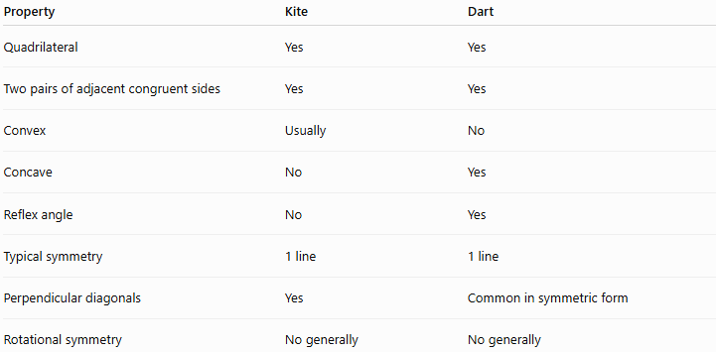
Property | Kite | Dart
Quadrilateral | Yes | Yes
Two pairs of adjacent congruent sides | Yes | Yes
Convex | Usually | No
Concave | No | Yes
Reflex angle | No | Yes
Typical symmetry | 1 line | 1 line
Perpendicular diagonals | Yes | Common in symmetric form
Rotational symmetry | No generally | No generally

Dart vs. General Concave Quadrilateral
# Source: AI Source: Provided by: [Data Path: Persons Table -> ID Column: 1, Name_En Column: Motasem Essam] -> From: [ChatGPT] on [7/25/2026]
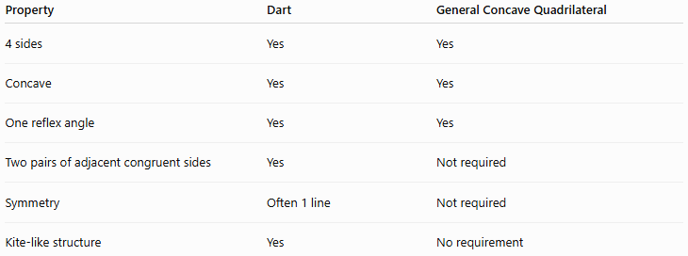
Property | Dart | General Concave Quadrilateral
4 sides | Yes | Yes
Concave | Yes | Yes
One reflex angle | Yes | Yes
Two pairs of adjacent congruent sides | Yes | Not required
Symmetry | Often 1 line | Not required
Kite-like structure | Yes | No requirement

Relationship with Kite
# Source: AI Source: Provided by: [Data Path: Persons Table -> ID Column: 1, Name_En Column: Motasem Essam] -> From: [ChatGPT] on [7/25/2026]
A useful classification is:
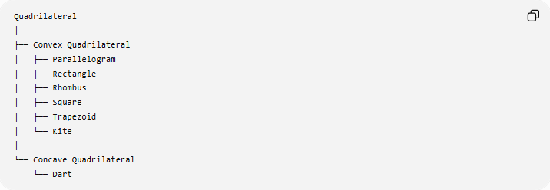
Quadrilateral
│
├── Convex Quadrilateral
│ ├── Parallelogram
│ ├── Rectangle
│ ├── Rhombus
│ ├── Square
│ ├── Trapezoid
│ └── Kite
│
└── Concave Quadrilateral
└── Dart
However, there is an important terminology point:
A dart is often treated as a special type of kite, specifically a concave kite. Some mathematical sources use kite broadly enough to include both convex and concave kites, while others reserve "kite" for the convex case and use "dart" for the concave case.
For your knowledge-base taxonomy, I recommend:
$$\boxed{\text{Kite}}$$
with
$$\boxed{\text{Dart-Shaped Quadrilateral}}$$
as a related concave form of a kite, rather than treating the dart as identical to the ordinary convex kite.

Real-World Applications
# Source: AI Source: Provided by: [Data Path: Persons Table -> ID Column: 1, Name_En Column: Motasem Essam] -> From: [ChatGPT] on [7/25/2026]
Dart-shaped forms can appear in:
- Decorative designs
- Jewelry
- Architectural patterns
- Textile patterns
- Logos
- Tiling
- Paper and craft designs
- Some structural and mechanical shapes
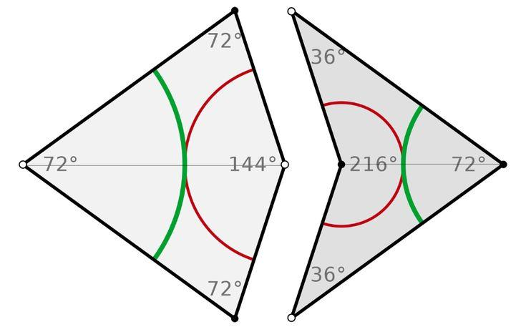
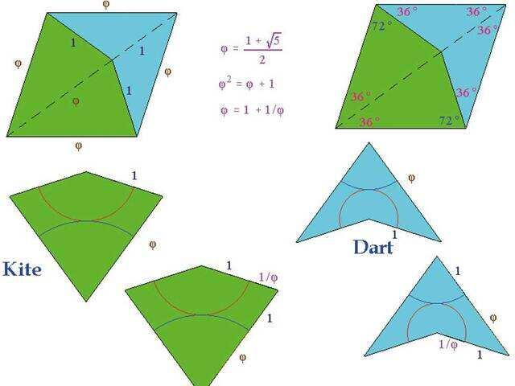

Advantages
# Source: AI Source: Provided by: [Data Path: Persons Table -> ID Column: 1, Name_En Column: Motasem Essam] -> From: [ChatGPT] on [7/25/2026]
- Provides a useful example of a concave quadrilateral.
- Demonstrates reflex angles clearly.
- Shows how side congruence can exist in concave figures.
- Symmetric darts have useful perpendicular and angle relationships.
- Can be analyzed using triangles and other simpler geometric figures.

Limitations
# Source: AI Source: Provided by: [Data Path: Persons Table -> ID Column: 1, Name_En Column: Motasem Essam] -> From: [ChatGPT] on [7/25/2026]
A general dart does not necessarily have:
- Parallel sides.
- Four equal sides.
- Four right angles.
- Congruent diagonals.
- Rotational symmetry.
- Two pairs of parallel sides.

Key Points
# Source: AI Source: Provided by: [Data Path: Persons Table -> ID Column: 1, Name_En Column: Motasem Essam] -> From: [ChatGPT] on [7/25/2026]
- A dart is a concave quadrilateral.
- It has two pairs of adjacent congruent sides:
$$\boxed{AB=AD, BC=CD}$$
- It has one reflex interior angle:
$$\boxed{{180}^{∘}<θ<{360}^{∘}}$$
- Its interior angles sum to
$$\boxed{{360}^{∘}}.$$
- A symmetric dart usually has one line of symmetry.
- A dart is commonly considered the concave counterpart of a kite.
- Its perimeter is
$$\boxed{P=2\left(a+b\right)}$$
when the two distinct side lengths are $a$and $b$.
- It does not generally have parallel sides or rotational symmetry.

Conclusion
# Source: AI Source: Provided by: [Data Path: Persons Table -> ID Column: 1, Name_En Column: Motasem Essam] -> From: [ChatGPT] on [7/25/2026]
A Dart-Shaped Quadrilateral (Dart) is a concave quadrilateral characterized by two pairs of adjacent congruent sides and a reflex interior angle. It can be viewed as the concave counterpart of a kite. Its distinctive concave shape makes it particularly useful for studying reflex angles, symmetry, diagonals, and the properties of concave quadrilaterals.

Arrow-Shaped Quadrilateral
# Source: AI Source: Provided by: [Data Path: Persons Table -> ID Column: 1, Name_En Column: Motasem Essam] -> From: [ChatGPT] on [7/25/2026]
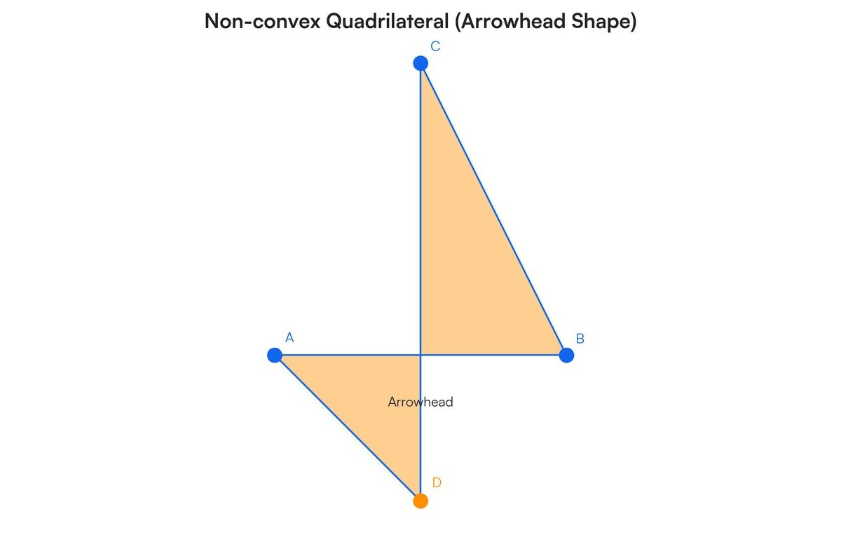
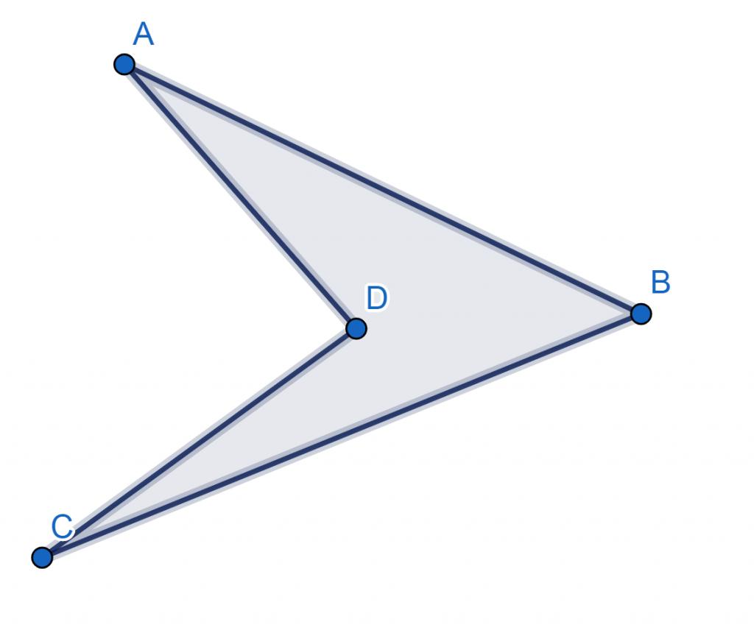

Definition
# Source: AI Source: Provided by: [Data Path: Persons Table -> ID Column: 1, Name_En Column: Motasem Essam] -> From: [ChatGPT] on [7/25/2026]
An Arrow-Shaped Quadrilateral is a concave quadrilateral whose shape resembles an arrowhead or the point of an arrow.
It typically has four sides and four vertices, with one interior angle being reflex, meaning it is greater than ${180}^{∘}$.
An arrow-shaped quadrilateral is commonly considered a special concave quadrilateral, and its geometry is closely related to the dart.

Fundamental Elements
# Source: AI Source: Provided by: [Data Path: Persons Table -> ID Column: 1, Name_En Column: Motasem Essam] -> From: [ChatGPT] on [7/25/2026]
An arrow-shaped quadrilateral has:
- 4 sides
- 4 vertices
- 4 interior angles
- 1 reflex interior angle
- 2 diagonals
- 1 concave indentation
- 1 arrow-like pointed region
For example, for quadrilateral $ABCD$:
$$AB, BC, CD, DA$$
are its four sides.

Main Characteristics
# Source: AI Source: Provided by: [Data Path: Persons Table -> ID Column: 1, Name_En Column: Motasem Essam] -> From: [ChatGPT] on [7/25/2026]
1. It is Concave
An arrow-shaped quadrilateral has at least one interior angle greater than ${180}^{∘}$.
$${180}^{∘}<θ<{360}^{∘}$$
Therefore:
$$\boxed{\text{Arrow-Shaped Quadrilateral}→\text{Concave Quadrilateral}}$$
2. Interior Angles
The sum of the four interior angles is still:
$$\boxed{{360}^{∘}}$$
Even though one angle is reflex.
For example:
$${40}^{∘}+{50}^{∘}+{60}^{∘}+{210}^{∘}={360}^{∘}$$
3. Four Straight Sides
Like every quadrilateral, its boundary consists of four straight line segments.
4. Arrow-Like Shape
Its vertices are arranged so that the quadrilateral visually resembles an arrowhead.

Mathematical Representation
# Source: AI Source: Provided by: [Data Path: Persons Table -> ID Column: 1, Name_En Column: Motasem Essam] -> From: [ChatGPT] on [7/25/2026]
Let the arrow-shaped quadrilateral be $ABCD$.
Its perimeter is:
$$\boxed{P=AB+BC+CD+DA}$$
Its interior angles satisfy:
$$\boxed{∠A+∠B+∠C+∠D={360}^{∘}}$$
with at least one reflex angle:
$$\boxed{{180}^{∘}<∠D<{360}^{∘}}$$

Area
# Source: AI Source: Provided by: [Data Path: Persons Table -> ID Column: 1, Name_En Column: Motasem Essam] -> From: [ChatGPT] on [7/25/2026]
There is no single universal area formula based only on the four side lengths.
The area can usually be found by decomposition.
For example, divide the arrow-shaped quadrilateral into triangles:
$$A_{\text{total}}=A_{1}+A_{2}+⋯$$
Alternatively, if the shape can be represented as an outer polygon minus an indentation:
$$\boxed{A_{\text{arrow}}=A_{\text{outer}}-A_{\text{indentation}}}$$
The appropriate method depends on the exact geometry.

Example
# Source: AI Source: Provided by: [Data Path: Persons Table -> ID Column: 1, Name_En Column: Motasem Essam] -> From: [ChatGPT] on [7/25/2026]
Suppose an arrow-shaped quadrilateral has interior angles:
$${40}^{∘}, {50}^{∘}, {60}^{∘}, {210}^{∘}$$
Check whether it can be a concave quadrilateral:
$${40}^{∘}+{50}^{∘}+{60}^{∘}+{210}^{∘}={360}^{∘}$$
and:
$${210}^{∘}>{180}^{∘}$$
Therefore, it has the required reflex angle and is consistent with a concave arrow-shaped quadrilateral.

Relationship with Dart
# Source: AI Source: Provided by: [Data Path: Persons Table -> ID Column: 1, Name_En Column: Motasem Essam] -> From: [ChatGPT] on [7/25/2026]
An Arrow-Shaped Quadrilateral is closely related to a Dart.
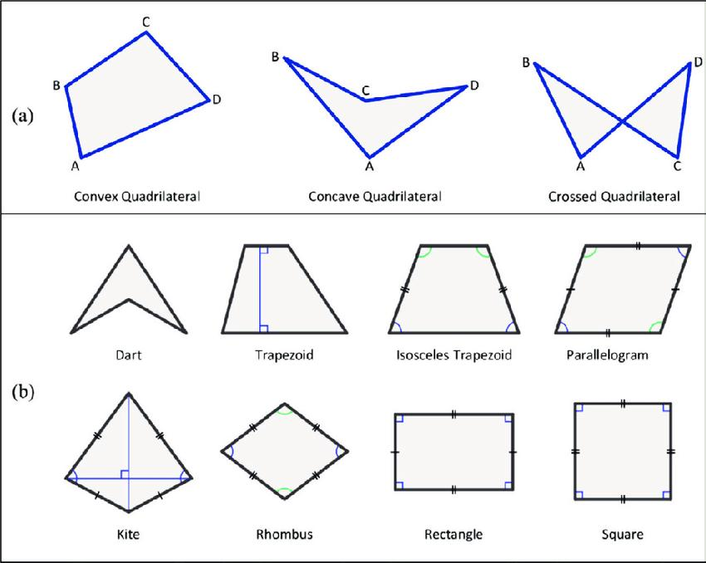
A dart is generally a concave quadrilateral with two pairs of adjacent congruent sides:
$$AB=AD$$
and
$$BC=CD$$
An arrow-shaped quadrilateral does not necessarily have these equal-side conditions.
Therefore:
$$\boxed{\text{Dart}⊆\text{Arrow-Shaped Quadrilateral}}$$
is not universally valid as a formal mathematical classification, because "arrow-shaped" is often a descriptive name rather than a standardized quadrilateral class.
For your knowledge base, the safest organization is:
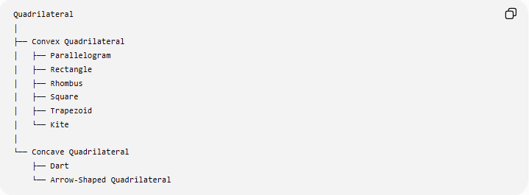
Quadrilateral
│
├── Convex Quadrilateral
│ ├── Parallelogram
│ ├── Rectangle
│ ├── Rhombus
│ ├── Square
│ ├── Trapezoid
│ └── Kite
│
└── Concave Quadrilateral
├── Dart
└── Arrow-Shaped Quadrilateral
However, Dart is the more mathematically established term. Arrow-shaped quadrilateral is better treated as a shape description unless your source specifically defines it as a separate class.

Comparison with Dart
# Source: AI Source: Provided by: [Data Path: Persons Table -> ID Column: 1, Name_En Column: Motasem Essam] -> From: [ChatGPT] on [7/25/2026]
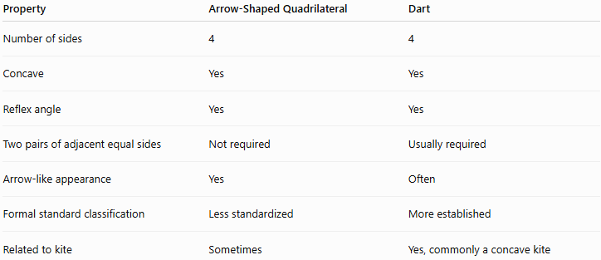
Property | Arrow-Shaped Quadrilateral | Dart
Number of sides | 4 | 4
Concave | Yes | Yes
Reflex angle | Yes | Yes
Two pairs of adjacent equal sides | Not required | Usually required
Arrow-like appearance | Yes | Often
Formal standard classification | Less standardized | More established
Related to kite | Sometimes | Yes, commonly a concave kite

Real-World Applications
# Source: AI Source: Provided by: [Data Path: Persons Table -> ID Column: 1, Name_En Column: Motasem Essam] -> From: [ChatGPT] on [7/25/2026]
Arrow-shaped quadrilaterals can appear in:
- Arrow symbols
- Direction signs
- Road markings
- Navigation graphics
- Interface icons
- Architectural designs
- Decorative patterns
- Mechanical components
- Game and diagram graphics

Key Points
# Source: AI Source: Provided by: [Data Path: Persons Table -> ID Column: 1, Name_En Column: Motasem Essam] -> From: [ChatGPT] on [7/25/2026]
- An Arrow-Shaped Quadrilateral has four straight sides.
- It is generally concave.
- It has at least one reflex interior angle.
- Its interior angles sum to:
$$\boxed{{360}^{∘}}$$
- It does not necessarily have equal sides.
- It is closely related to the dart.
- Dart is the more established geometric term; arrow-shaped is often descriptive.

Conclusion
# Source: AI Source: Provided by: [Data Path: Persons Table -> ID Column: 1, Name_En Column: Motasem Essam] -> From: [ChatGPT] on [7/25/2026]
An Arrow-Shaped Quadrilateral is a concave four-sided figure whose arrangement of vertices gives it an arrow-like appearance. For a rigorous mathematical taxonomy, I recommend placing it under Concave Quadrilaterals, while treating Dart as the more specific established type when the two pairs of adjacent sides are congruent.

